THE PASSIVE VOICE

Complete the sentences with the correct passive form of the verbs in brackets. Use the present simple.

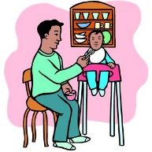
1. The baby …………… (feed) | 2. The phone call ……….… (answer) by the receptionist. | 3. We ………........ (serve) by the waitresses. | 4. The cow ………… (milk) by the farmer | 5. Fancy dress costumes………..… (wear) at Carnival.
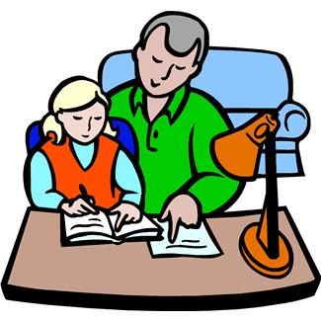 |  | 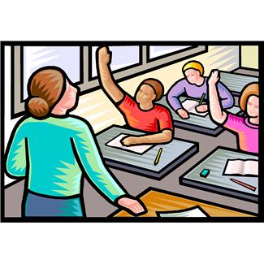
6. I ……… (help) by my father. | 7. The dishes ………….. .(wash) | 8. Questions ……….. (ask) to the teacher. | 9. Mother …………. (drive) to work by dad. | 10. The car ……….. (repair) by the mechanic.
 | 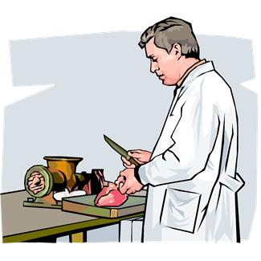 | 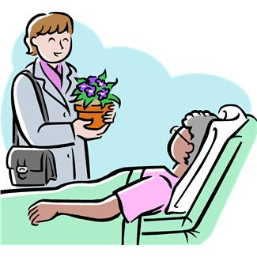
11. Letters …………… (type) by the secretary. | 12. Meat …………… (sell) at the butcher’s. | 13. Granny ……… (visit) at hospital. | 14. Coffee …………. (grow) in Colombia. | 15. The trousers …………….. (iron).
 | 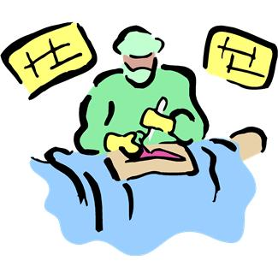 |  |  | 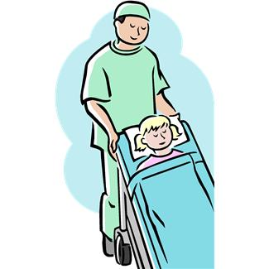
16. Sushi ………. (eat) in Japan. | 17. The operation ……………. (perform) by the surgeon. | 18. A book ……… (borrow) from the library. | 19. The problem ………. (explain) by the teacher | 20. The patient …………..(carry) by  The orderly.
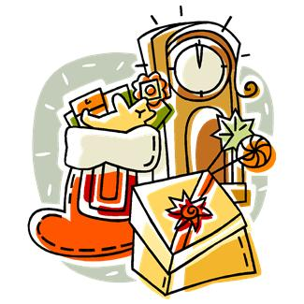 |  | 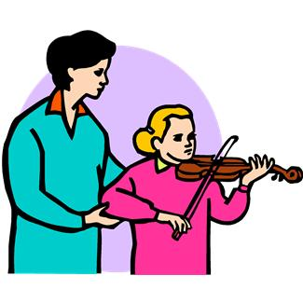 | 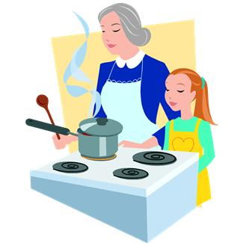 | 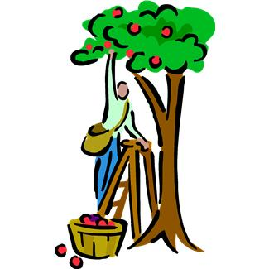
21. Presents …………… (give) at Christmas. | 22 The exam …………. (do) by the student. | 23. The violin ……….. (play) by Carol. | 24. Lunch …….. (cook) by Sally and her grandma. | 25. Apples ………… (pick up) in summer.

