

We use comparatives adjectives when we want to compare two people or two things.

Example: *My cat is* ***smaller*** *than your cat.*

*The girl is* ***taller*** *than the boy.*

COMPARATIVES

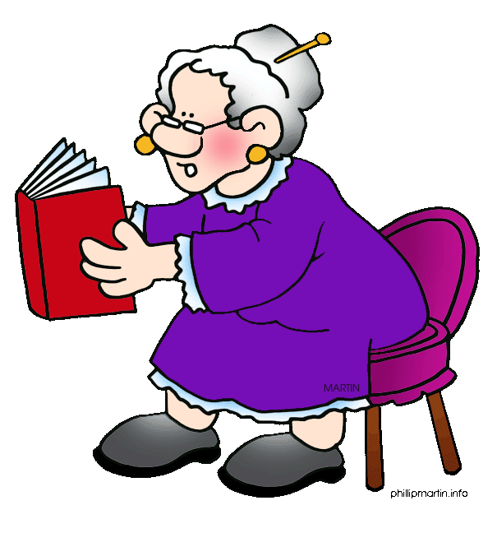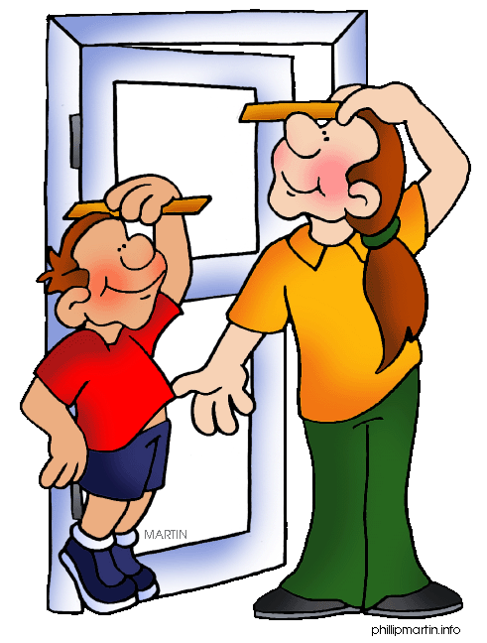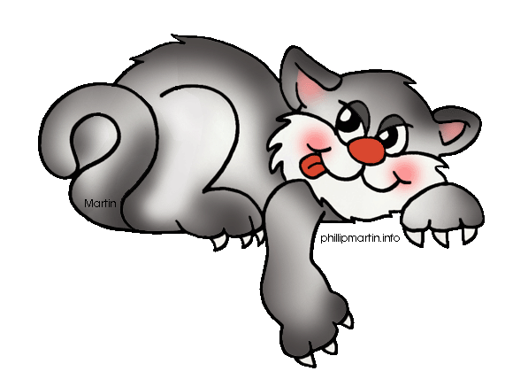

Complete the sentences with the correct comparative adjective

1.- Mary’s hair is ………… (long) than Elizabeth’s hair.

2.- Daniel’s shoes are …………….. (cheap) than Alice’s shoes.

3.- Your eyes are ……………. (big) than mine.

4.- The cinema is ………….. (near) than the hospital.

5.- My room is ……………… (modern) than her room.

6.-The school bus is …………. (new) than my mom’s car.

7.-Frederick is …………. (rich) than Richard.

8.-My grandmother is …………. (intelligent) than my grandfather.

9.-Sonia’s drawings are …………… (good) than Julio’s

10.- Planes are ………….. (fast) than trains.

11.-Yesterday was ……….. (cold) than today.

12.-Magazines are ……… (entertaining) than school books.

13.- Tortoises are …….. (slow) than hares.

14.- Chinese is …………… (difficult) than French.

15.- Your hair is ………… (dark) than my hair.

16.-The kid is …….. (short) than the girl.

17.- Fruit and vegetables are ……… (healthy) than fast food.